Prerequisite: Vagrant installed
Steps:
- Create VagrantFile and initialize Ubuntu VM
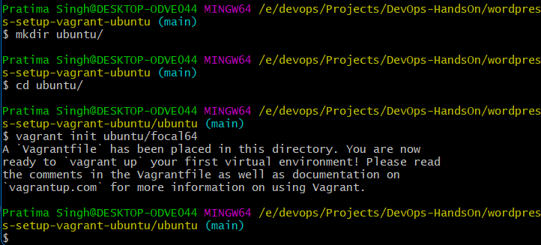
- Open VagrantFile using vim and get into Insert mode
- Uncomment private and public network configuration lines. Assign a static private IP
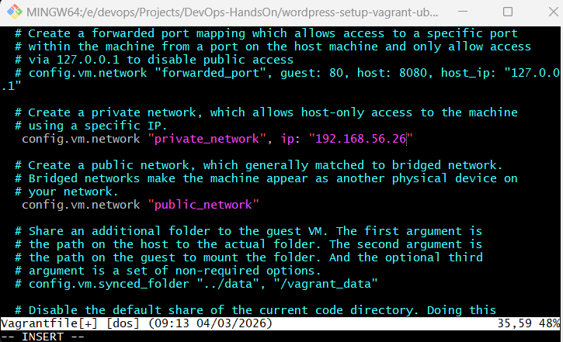
- Can upgrade memory to 1600MB
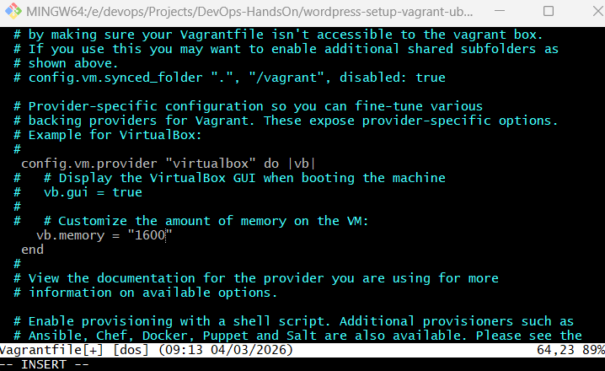
- Save and quit. Turn up the VM
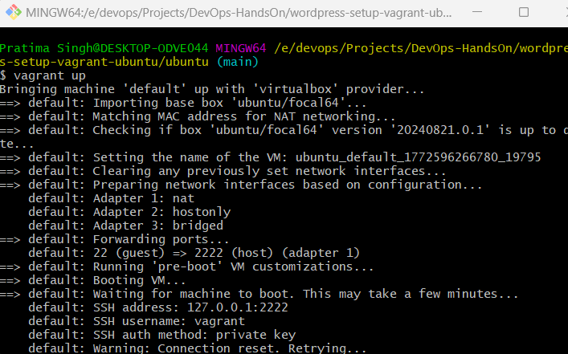
- Login to VM and switch to root user
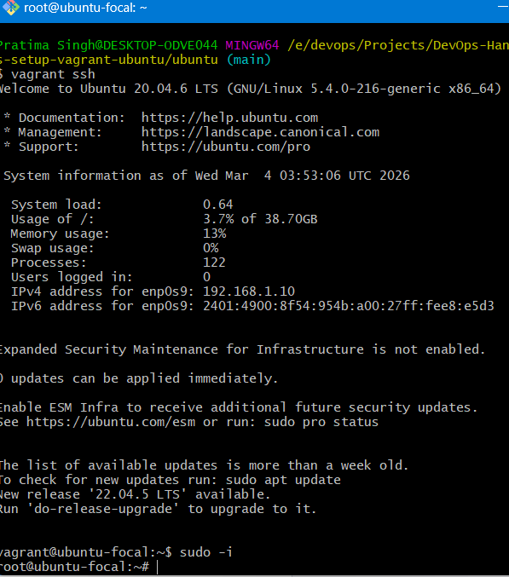
- Edit /etc/hostname (Changing hostname). Save and quit
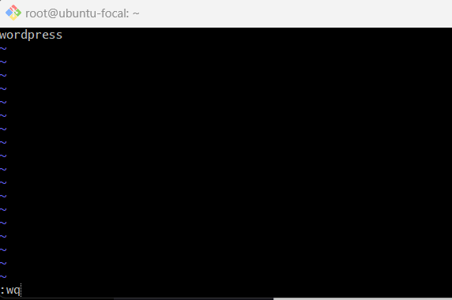
- Logout from the VM and login again for the change to get applied
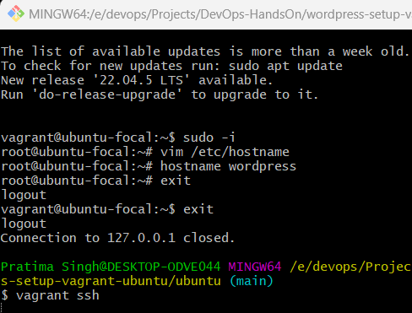
- Refresh local Linux package index to check for latest updates without installing them
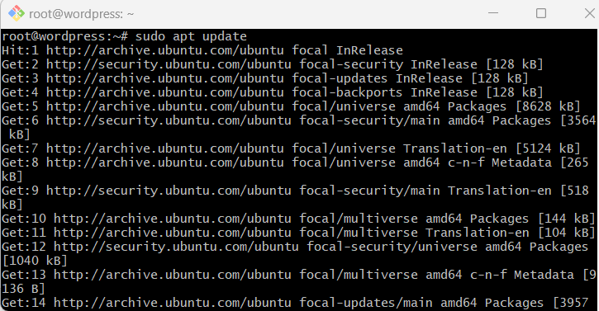
- install PHP(PHP engine for Server-side Scripting – generates html), Apache (for http server) and mysql-server(database server)
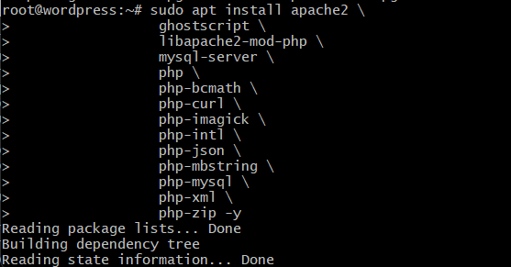
- Make directory /srv/www
sudo mkdir -p /srv/www
- Assign ownership of this directory to default web services user “www-data”
sudo chown www-data: /srv/www

- Get wordpress tar file from specified link using curl. And extract it into /srv/www
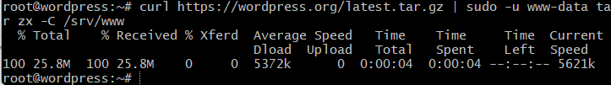
- Check ownership and directory permissions of /srv/www
- Check all files present in this directory
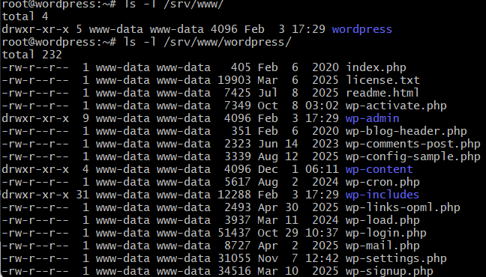
- Create Apache site for WordPress by editing the below config
vim /etc/apache2/sites-available/wordpress.conf
<VirtualHost *:80>
DocumentRoot /srv/www/wordpress
<Directory /srv/www/wordpress>
Options FollowSymLinks
AllowOverride Limit Options FileInfo
DirectoryIndex index.php
Require all granted
</Directory>
<Directory /srv/www/wordpress/wp-content>
Options FollowSymLinks
Require all granted
</Directory>
</VirtualHost>

- Enable the site wordpress
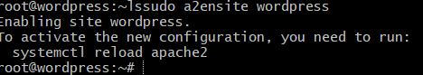
- Enable URL rewriting
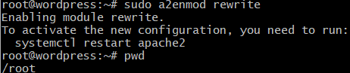
- Disable the default “It Works” site with:
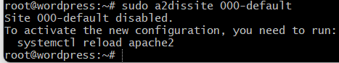
- reload apache2 to apply all these changes
- Check /etc/apache2/sites-enabled/ directory to view a link file for wordpress.conf
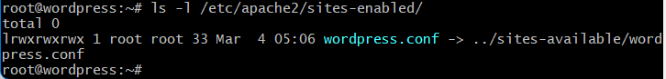
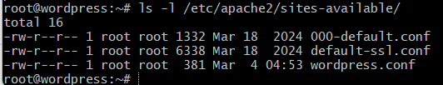

Configure database:
- Login to mysql as root user
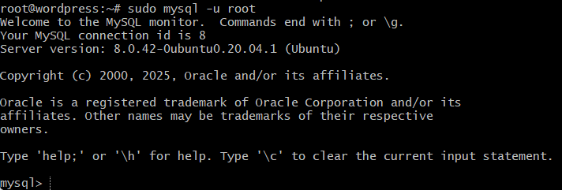
- Create database – wordpress
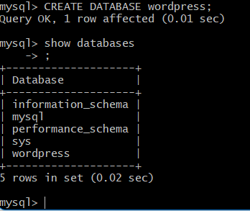
- Create user- wordpress on localhost and give it a password
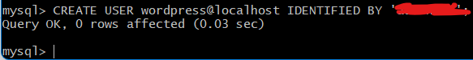
- Grant required permissions to this user on the ‘wordpress’ database
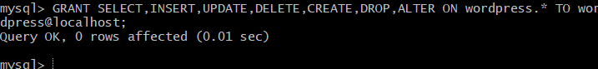
- Reload the grant tables without server reload
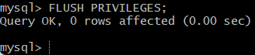

Configure WordPress to connect to the database
- copy the sample configuration file to wp-config.php
- set the database credentials in the configuration file
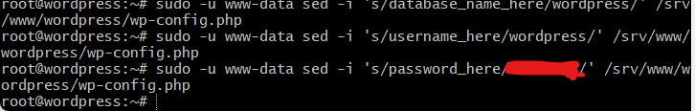
Note: sed command is used to replace keywords in any file
- Open this config file with www-data user
sudo -u www-data vim /srv/www/wordpress/wp-config.php
- Replace the following credentials: Salt keys, auth keys,etc
define( 'AUTH_KEY', 'put your unique phrase here' );
define( 'SECURE_AUTH_KEY', 'put your unique phrase here' );
define( 'LOGGED_IN_KEY', 'put your unique phrase here' );
define( 'NONCE_KEY', 'put your unique phrase here' );
define( 'AUTH_SALT', 'put your unique phrase here' );
define( 'SECURE_AUTH_SALT', 'put your unique phrase here' );
define( 'LOGGED_IN_SALT', 'put your unique phrase here' );
define( 'NONCE_SALT', 'put your unique phrase here' );
- Search your VM static or bridge adaptor IP and fill in the details to install wordpress
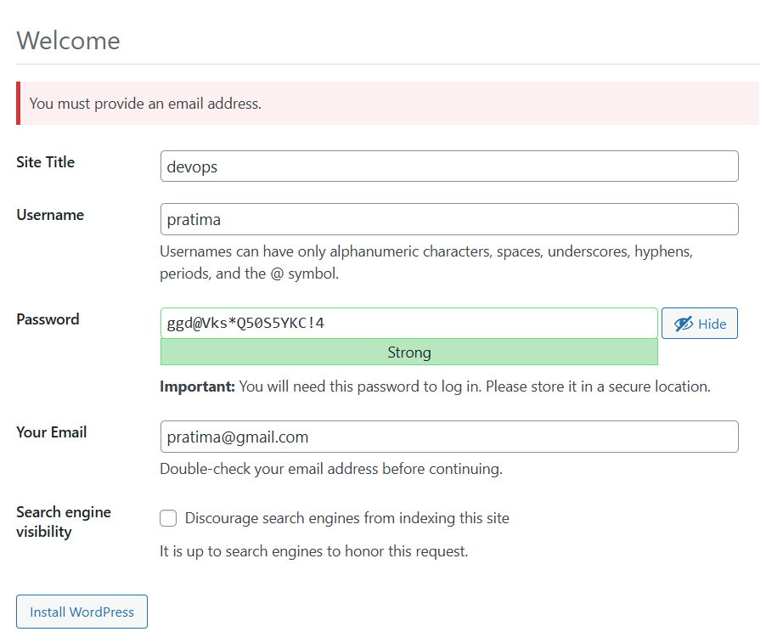
- Login
